CSCI 6609 UBIQUITOUS COMPUTING

Quiz Board

Mile Stone-1

**Neel Patel**

**Emmanuel Kuatsidzo**

**James Hill**

**Research Question**

How context (environmental) affects users’ interaction with ubiquitous systems (Quiz Board)?

Does change in location affect performance of the user?

**Description**

A user's environment plays an essential role in his interaction with ubiquitous systems for the performance of tasks [1]. Users’ may find certain factors in their environment favourable, which keeps them engaged in performing tasks and interacting with ubiquitous systems. For this project, we will be developing an application that will utilize mobile devices and large screen displays located at central points in various departments. These large displays will post questions which users within its vicinity can answer. The study will examine the factors in the user's environment responsible for performing tasks on the basis of the total number of answers received from each location.

Apart from these, we will also look into the number of students who preferred alternative location, since they had an option to answer the same questions from their own department. Studies show that performance of the task (learning behaviour) also depends on the physical environment of the space [2]. Also, by tracking the location of the user [3], each time he takes part in quiz, we will be able to determine if there is a change in his performance. Wireless Sensor Networks (WSN) can be installed in different departments in order to track near to exact users’ location.

**References**

1. John Krumm. 2009. *Ubiquitous Computing Fundamentals* (1st ed.). Chapman & Hall/CRC.
2. [http://www.vit.vic.edu.au/SiteCollectionDocuments/PDF/1137_The-Effect-of-the-Physical](http://www.vit.vic.edu.au/SiteCollectionDocuments/PDF/1137_The-Effect-of-the-Physical-Learning-Environment-on-Teaching-and-Learning.pdf)- [Learning-Environment-on-Teaching-and-Learning.pd](http://www.vit.vic.edu.au/SiteCollectionDocuments/PDF/1137_The-Effect-of-the-Physical-Learning-Environment-on-Teaching-and-Learning.pdf)f
3. Service-Oriented Computing - ICSOC 2003, Volume 2910, Lecture Notes in Computer Science, Orlowska, MariaE. And Weerawarana, Sanjiva and Papazoglou, Michael. And Yang, Jian, 10.1007/978-3-540-24593-3_36, Location-Based Services in Ubiquitous Computing Environments,  [http://dx.doi.org/10.1007/978-3-540-24593-3_36,](http://dx.doi.org/10.1007/978-3-540-24593-3_36) Springer Berlin Heidelberg, Satoh, Page 527-542

**Project Description**

The environmental context in which a device is located can affect how a user interacts with the device. For this project, the group will be developing an application that will utilize large screen displays and mobile devices.

The application will test students with questions that are created by each of the participating departments in the university. The large display will be used to display questions that would be rotated after a set period of time. The users would then use a mobile application to select an answer to the posted question. To answer questions, users must be within range of a large display. However, if they are not within range, the application will display only statistics of the user. Users will be able to select sub topics to give a range of questions outside their discipline. A leader board will list users based on points that they collected when correctly answering questions. The program will track the types of question answered and the numbered that where correctly answered. The application will also track location in which users attempted the question. This statistics will be available to the department and processed and presented to the users on the large display. Students can also use the mobile application to bookmark questions and access the answer when available.

**Paper Prototyping**

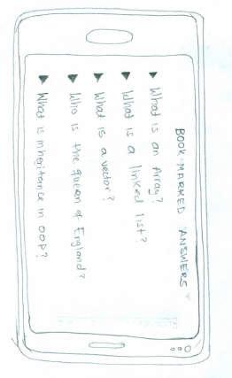

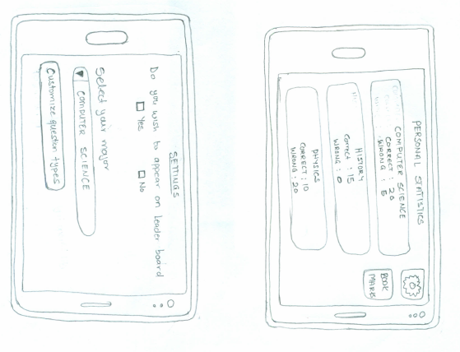

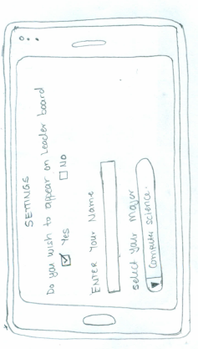

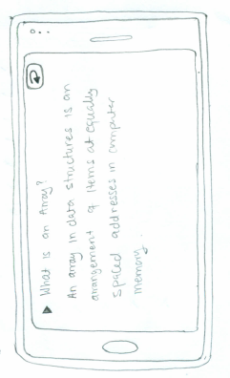

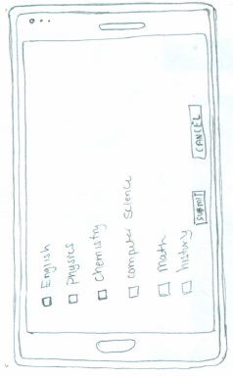

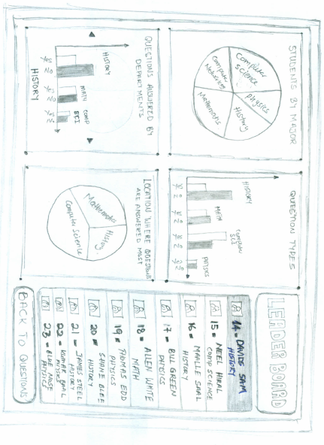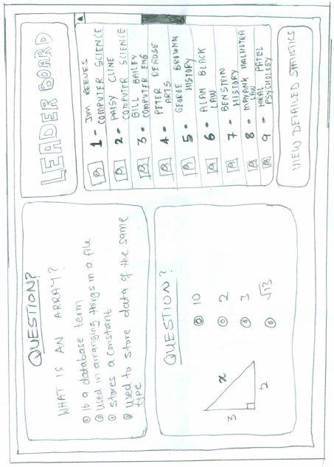

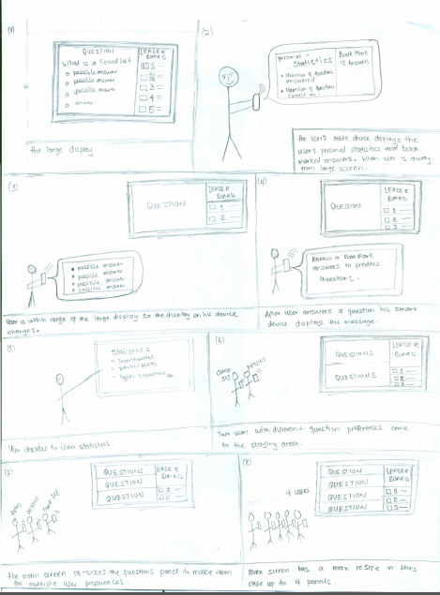

**Document outlining the pre-trial**

To implement our ideas described in above section, we prepared paper-prototype of our design. The potential users of the application evaluated the design of the application on the basis of the paper-prototype. The usability of the application was assessed and the potential challenges that we could face were discussed with the users. One of the major challenges was notifying the participants about the quiz they could take part in, as pass by near the main screen.

**Document outlining the pre-trial**

Finding: When a user selects an answer on the mobile device there is no feedback as to if they have selected and submitted an answer.

Change: The application will spawn a window stating that their answer has been successfully submitted. This window will also include a button that will allow the user to bookmark this question so that they can check for the answer later.

Finding: Currently the user cannot change their answer after the first submission. For example if a user was to change their mind about an answer or accidently hit an incorrect answer they are unable to change it to a different answer.

Change: The user will be able to select another answer as they would normally answering the question for the first time. When selected though the user will be asked via a popup window if they indeed wish to change their answer.

Finding: When the user navigates to a question that has been bookmarked in order to read the answer to the problem only the expanded version of the answer is shown. This does not match the answers that where provided with the question.

Change: Include the actual answer with the expanded version.

Finding: The bullet points used in the application are the triangles that are used to represent when an item can be expanded to show more information. These items do not expand and may confuse users.

Change: Use different bullet points such as circles.

Finding: When the large display is idling most of the screen will be blank as this space is taken up by the question and its answers.

Change: Cycle through some of the current questions so as to draw users to the display and answer questions. This also means that the large display does not have wasted space when idling.

Finding: Under the statistics screen on the large display the users is unable to expanded the graphics to see greater detail.

Change: Allow the user to tap on a graph so that it can be enlarged to give the user greater detail.